**Design Doc**

**When we get into the game play and click on the piece**

**Tech Stack:**

**Language: Python**

**IDE:VS CODE**

**PyQt**

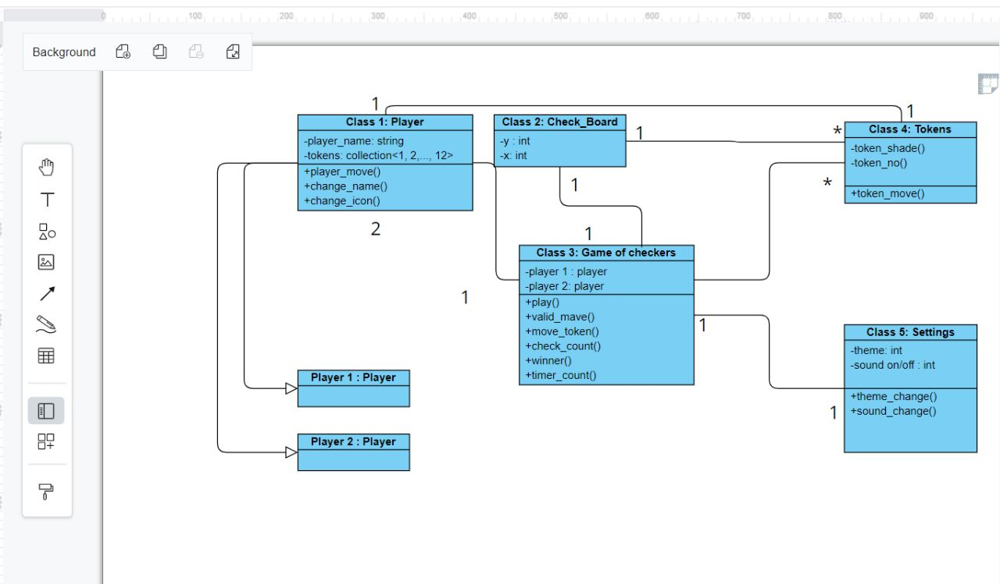

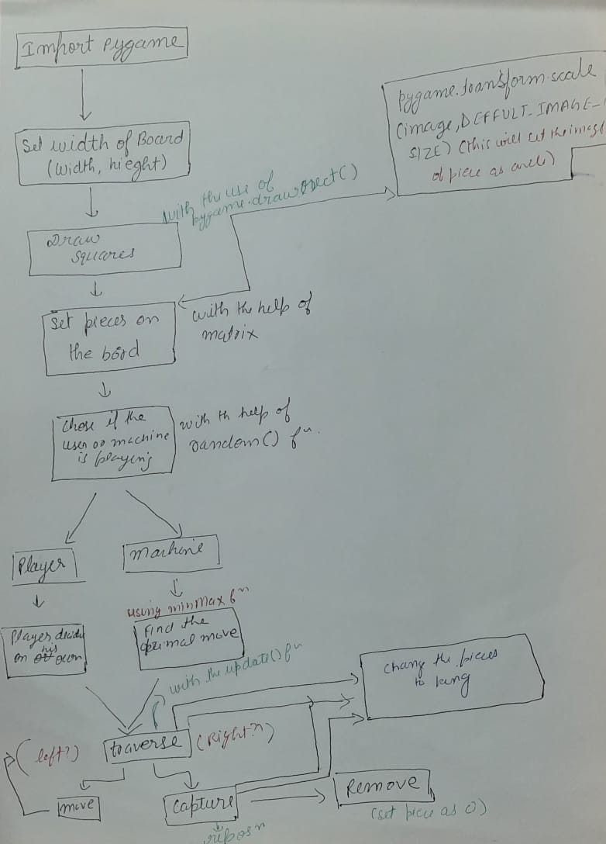

**N-ary Game Tree:**  
  
For finding the optimal move of the checker board that can be made by the machine, N-ary Game tree is generated based on the contemporary state of the checker board by fixing the depth. The N-ary Game tree is generated as follows.

**Step 1:** The initial node that is the root node consists of the contemporary state of the checker board.  
**Step 2:** And the forthcoming levels of the tree consist of all possible moves that can be made by the machine and the opponent alternatively.  
**Step 3:** Step 2 is repeated until the game tree of depth n gets generated.  
**Step 4:** Heuristic value is calculated for all the leaf nodes of the game tree.

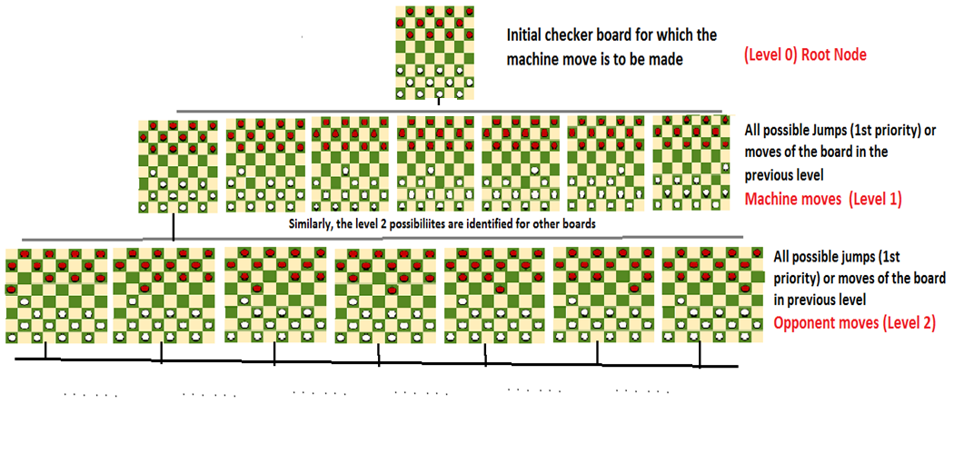

Opponent move

**Heuristic Value:**  
For a checker board

1. The pawns of the machine are given value **1.**
2. The Kings of the machine are given value **2** (since these are favorable for the machine to win)
3. The pawns of the opponent are given value **-1**(since these are less favorable for the machine to win)
4. The kings of the machine are given value **-2** (since these are unfavorable for the machine to win)

And the sum of those values present in the checker board is calculated and it is known as the heuristic value of the checker board, more the heuristic value more the favor for the machine to win the game.

## Terminology

* **Game Tree**: It is a structure in the form of a tree consisting of all the possible moves which allow you to move from a state of the game to the next state.

A game can be defined as a search problem with the following components:

* **Initial state**: It comprises the position of the board and showing whose move it is.
* **Successor function**: It defines what the l
* egal moves a player can make are.
* **Terminal state**: It is the position of the board when the game gets over.
* **Utility function**: It is a function which assigns a numeric value for the outcome of a game. For instance, in checkers , the outcome is either a win, a loss, or a draw, and these can be represented by the values +1, -1, or 0, respectively.